Code No.: |  | HTU/P18 |  | Date Established | 9/11/2017
Responsible  Department |  | Quality Assurance |  | Date Posted | 9/11/2017
Responsible Executive |  | Program leader & Head of Departments |  | Date Last Revised  Revision # 3 | 17/11/2023
Quality Nominee |  | Rumiana Bahova Nuseibeh |  | Forwarded Revision Date | 17/11/2024

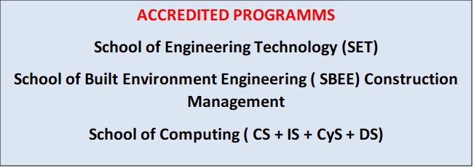

This Document was last revised : 17th November 2023

Staff development policy
Summary

Understanding the conditions through which teachers’ acquisition and use of new knowledge and skills are enhanced informs our understanding of effective models of professional development.

POLICY STATEMENT

This recognized that the success of the center depends on all staff whatever their role having the relevant skills, knowledge and competencies.

RESPONSIBILITY
• Head of departments to identify their staff needs and report to the top management to provide the suitable courses to the staff members.

PROCEDURE

• Staff development provided by the college is informed by its strategic aims and operational requirements, taking into account the needs of the individuals and where possible the career aspirations of staff as well as the success of their departments.
• Departments work alongside the Learning and Development team to develop a coordinated approach to planning staff development, maximizing the use of available resources.
• Leaders and Managers are provided with the skills, knowledge and competencies they need to work in partnership with their staff to support their continuous development.
• All staff are supported and encouraged to acquire and develop the relevant knowledge, skills and competencies to enhance their performance in their current role and, where they are involved in succession planning, for their next role within the University.
• To provide the appropriate support to our contract research staff to enable them to develop their careers.
• An appropriate balance is created between the desire for individual staff members to maximise their potential and for the University to obtain a return on its investment in staff development.
• All staff receive an appropriately organised University and local induction in timely fashion.
• Staff develop the skills to respond effectively to internal and external demands.

The Quality Nominee at HTU Centre, makes sure to share with faculty all related to the qualification support material, news and online training, in addition to regular induction seminars in view of internal verification, assessment process and many other details.
In addition a CPD Unit was established at HTU with an approved framework for the implementation of co ntinued professional development for HTU’s faculty and staff.

• There are appropriate controls in place to enable all staff to be trained at the levels appropriate to their role, in order to ensure the University is compliant with respect to its statutory and legal obligations.

End of Policy.

